8.請嘗試使用一些簡單的財務知識，來驗證本章的計算存續期間的範例程式產生的答案是否合理。假定債券支付的債息為 0，則其存續期間應為多少？ 請問當債息提高（或下降），存續期間應提高還是下降？ 並將推論的結果輸入範例程式中，驗證推論的結果是否和程式的輸出相符合。

MD of a zero-coupon bond is it’s final maturity (n).

Proof: because no cash flows before maturity, the MD is

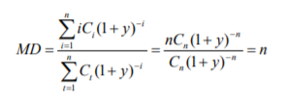

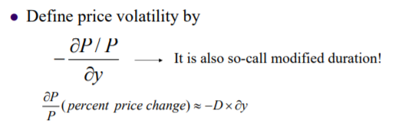

Price volatility increases as the coupon rate decreases.

Bonds selling at a deep discount are more volatile than those selling near or above par.

Zero-coupon bonds are the most volatile.

Coupon越低的話，Face value影響bond price 的占比越來越重，那整體的Price volatility會增加

Macaulay duration = Modified duration * (1 + y) and Price volatility (Modified duration) increases as the coupon rate decreases.

Thus, if the yield doesn’t change, Modified duration decreases as the coupon rate increases.

債券支付的債息為 0，則其存續期間應為n期

當債息提高，存續期間應下降

Coupon = 0

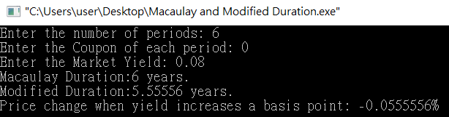

Coupon = 8

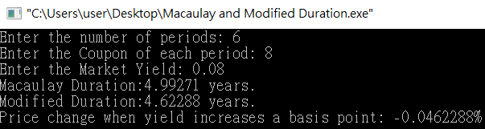

Coupon = 10

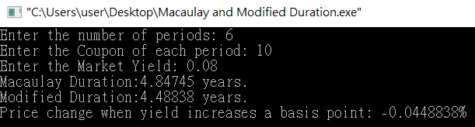

當債息提高，存續期間下降

|  |  |  |
| --- | --- | --- |
| Coupon | Macaulay Duration | Modified Duration |
| 0 | 6 | 5.5556 |
| 8 | 4.99271 | 4.62288 |
| 10 | 4.84745 | 4.48832 |